Top of Form

Bottom of Form


Business Requirement Documentation for Transfer & Relocation (“To Be Transfer” Process) Development

Version and Approval

Version History
Version # | Date |  | Revised By | Reason for change
1.0 | 14-12-2022 |  | Bhavin Patel | Initial

This document has been approved as the official Business Requirements Document for Transfer & Relocation “To Be Transfer” Process, and accurately reflects the current understanding of business requirements. Following approval of this document, requirement changes will be governed by the project’s change management process, including impact analysis, appropriate reviews and approvals.

Project Details

Project Name | Transfer & Relocation Project (Part 1: To Be Transfer Process)
Project Type | Web Based
Division | HR
Project Manager/Dept

Project Overview

AUMENTO’s understanding is based on the meetings and information provided to us by HMSI. The company has strong and focused Plans to automize the transfer and relocation process using web-based portal that acts as an interface for all communications between HR and Associates, to save resources and eliminate human errors by automizing system. Where a strong, trusted, secured and scalable IT solution is required.

Having an Integrated Transfer and Relocation Web Portal Solution for HR, Users & Associates.
- To be Transfer initialization process
- Look and See process.
- Look and See settlement.
- Relocation process.
- Relocation settlement process.

Process Flow – To Be Transfer

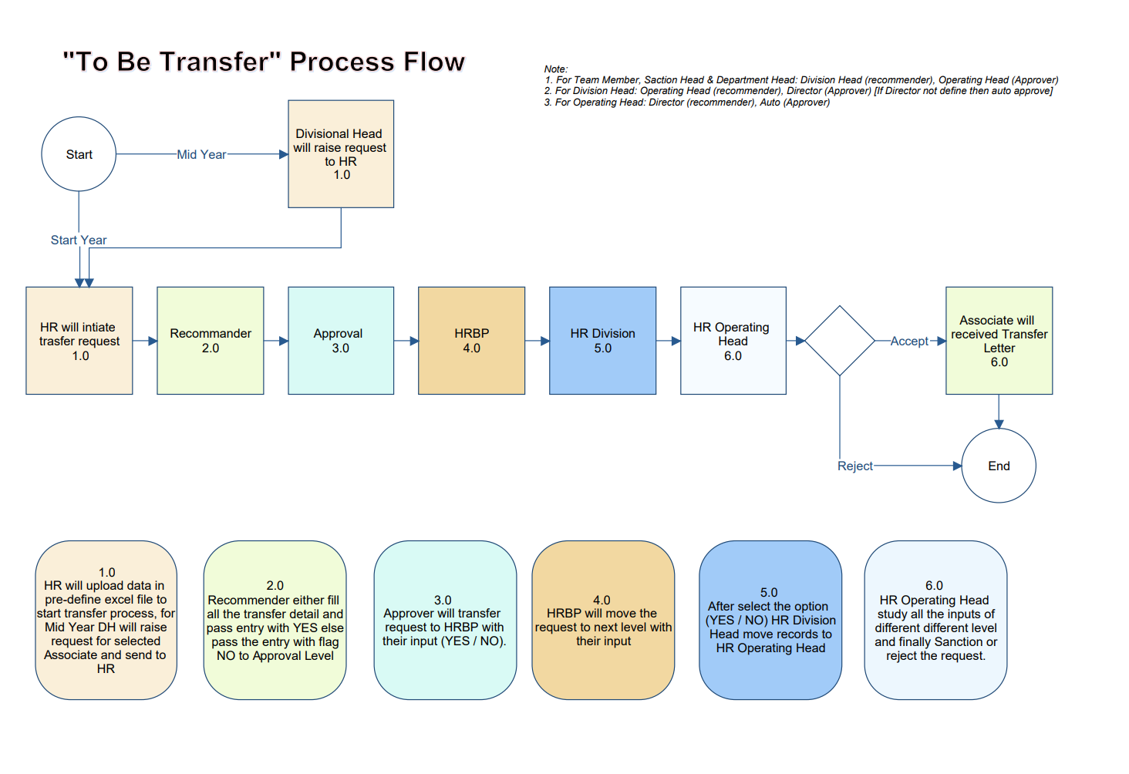

HR User – Excel Import (Start Year)
- Concern HR user will upload excel file in system with below data.
  - Employee Code
  - Reference Date
  - HRBP User
  - Tenure
  - HR Recommendation
- After the import HR user will submit whole bunch and it will be move to concern recommender for further course of action.

Division Head (Mid Year)
- In between the year if Division Head wants transfer of any Associate then they will raise request and send to HR with below details.
  - Employee Code
  - Remarks

Recommendation
- Recommender will fill the details i.e. Transfer Date, New Operation, Division, Department, Section and Location where Associate will be transfer.
- Recommender will also give their opinion for Is Transfer required or not, if Transfer not required then Justification for particular Associate is compulsory required.
- After the fill all details Recommender will submit whole bunch to next level – Approval.

Approval
- Approver will give their opinion for each Associate and if required then Approver will put their Remarks and send whole bunch to next level - HRBP.

HRBP
- HRBP will give their opinion for each Associate and if required then HRBP will note their Remarks. After the give opinion for all the Associates HRBP will send whole bunch to next level - HRDH.

HRDH – HR Division Head
- HRDH will give their opinion for each Associate with their remarks if required. After the giving opinion for all the Associates HRDH will send whole bunch to next level - HROH.

HROH – HR Operating Head
- HROH will give their opinion for each Associate with their remarks. HROH can Re-send whole bunch to HR 1st level if not found satisfactory data for any one Associate. In this case HR will generate whole request again. If HROH will approve the whole bunch then system will generate Transfer Letter for Associates.

Common Notes:
- If Recommender’s opinion for Transfer is “NO” and other stage required to transfer the particular Associate then at that level all the transfer related information should be fill.
- Each Associate has one Recommender, one Approval, one HRBP, one HRDH and one HROD. Admin and Finance will be Role wise.
- Each level have to process all the records at one stroke same time. i.e. At Recommend Level there are 10 Associates. Recommender have to submit all the 10 records at one stroke. Recommender cannot pass few records out of this 10 to next level.

MIS Reports

- Discussion is pending.

Approval Matrix

Sr. No. | Name | Recommender | Approver
1 | Team Member | Division Head | Operating Head
2 | Section Head | Division Head | Operating Head
3 | Department Head | Division Head | Operating Head
4 | Division Head | Operating Head | Director
5 | Operating Head | Director | Auto

Screen Design

- Refer Annexure-A.

For: Aumento Technologies & Consulting Services Pvt Ltd
Bhavin Patel
Lokesh Shah
Kavan Shah

